SMART HOSTEL ROOM AUTOMATION
AND
POWER MONITORING SYSTEM
Capstone Project Report

Samsung
Innovation Campus
Submitted by
Bhavana M P – 4GW24CI007
Snehaganga N S – 4GW24CI048
Lisha S Kumar – 4GW24CI021
Department of Computer Science Engineering
(Artificial Intelligence & Machine Learning)
GSSSIETW(R)
Mysuru

Under the Guidance of
Sharat Kanthi

Contents

Section | Page
1.Title | 1
2. Abstract | 2
3. Problem Statement | 3
4. Objectives | 4
5. Architecture Diagram | 5
6. Technologies Used | 6
7. Implementation | 7
8. Results / Output | 8
9. Challenges Faced | 9
10. Future Improvements | 10
Capstone Project Document

Title :
Smart Hostel Room Automation and Power Monitoring System Using IoT

Abstract :
- The Smart Hostel Room Automation and Power Monitoring System is an IoT-based solution that allows students to remotely control appliances like lights and fans while monitoring power consumption to improve energy efficiency in hostels.
- Data from ESP32 devices is processed by a Raspberry Pi and stored on cloud platforms such as Google Sheets for tracking and analysis of power usage.

Problem Statement :
- In many hostels, electrical appliances like lights and fans are often left running even when rooms are unoccupied, leading to energy wastage and higher electricity costs. Additionally, there is limited visibility into individual room power usage.
- A smart system is required to monitor energy consumption and allow remote control of devices for efficient power management.

Objectives :
- To develop an IoT-based smart system for controlling hostel room appliances remotely.
- To monitor electricity usage of hostel rooms in real time.
- To store power consumption data for analysis and tracking.
- To reduce unnecessary electricity consumption in hostel rooms.
- To create a scalable system that can be implemented across multiple hostel rooms.

Architecture Diagram :

Mobile App
↓
MQTT Broker
↓
Raspberry Pi (Edge Processor)
↓
ESP32 Microcontroller
↓
Relay Module → Lights/Fans
↓
Power Controller → Data Monitoring
↓
Cloud Storage (Google Sheets)

Technologies Used :
Hardware
- ESP32 Microcontroller
- Raspberry Pi
- Relay Module
- Breadboard and Jumper Wires

Software
- Python
- MQTT Protocol
- Mosquitto MQTT Broker
- Google Sheets API
- WiFi Communication

Platforms
- Raspberry Pi OS
- GitHub for version control

Implementation (Git) :
The implementation of the project is managed using Git for version control. All source code including ESP32 scripts, Raspberry Pi Python scripts, and documentation are maintained in a Git repository for collaboration and version tracking.

https://github.com/BhavanaMP1111/smart_hostel_automation.git

Results / Output :
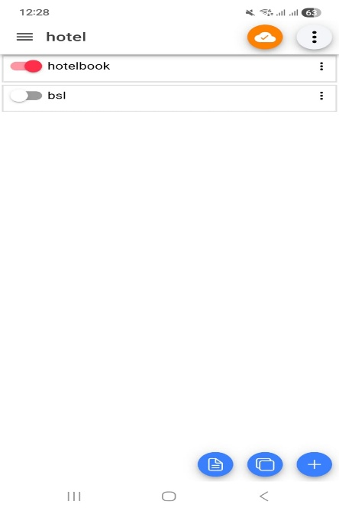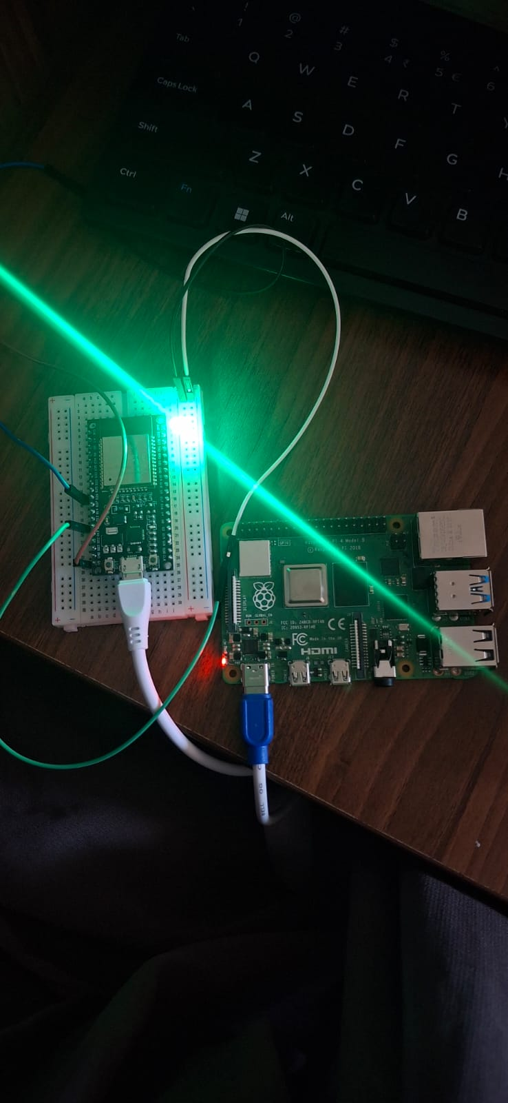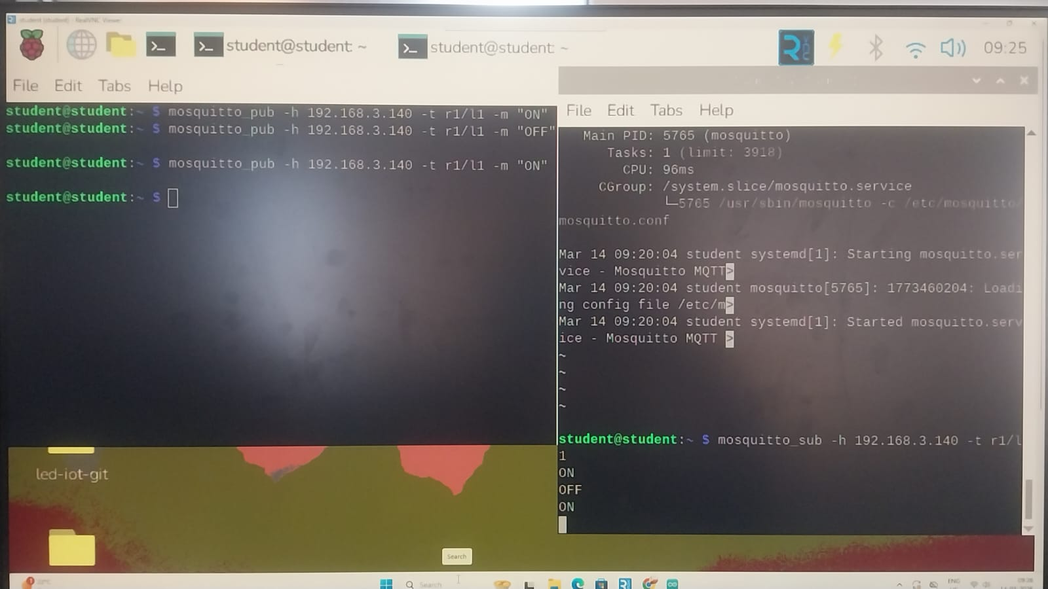

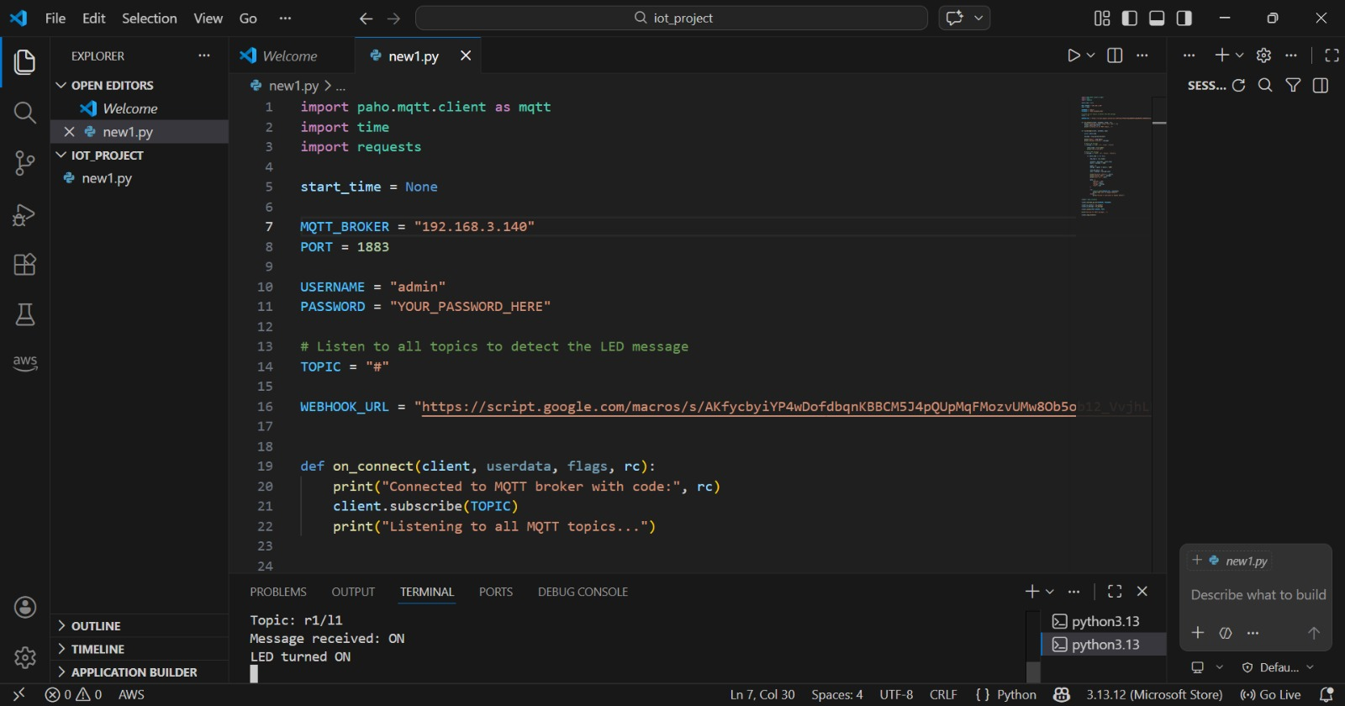

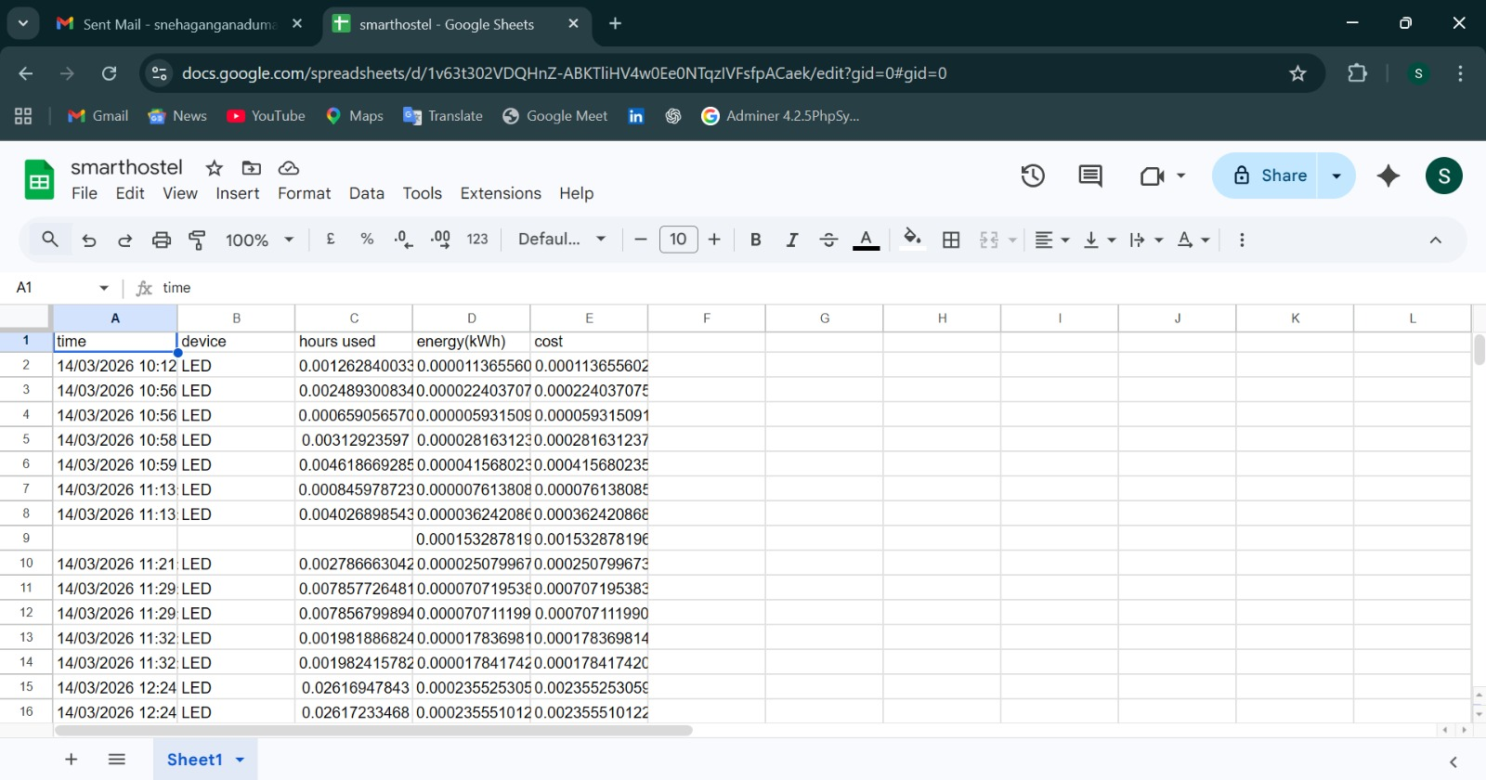

Challenges Faced :
- Establishing stable communication between ESP32 and Raspberry Pi.
- Handling MQTT message reliability and connectivity issues.
- Integrating cloud services such as Google Sheets API.
- Managing real-time data processing and filtering at the edge device.
- Hardware wiring and power supply management during testing.

Future Improvements :
- Integration of a mobile application for user-friendly control.
- Addition of AI-based energy consumption analysis.
- Integration of smart sensors such as smoke detectors and motion sensors.
- Development of a dashboard for real-time visualization of power data.
- Scaling the system to support multiple hostel rooms and buildings.

